# BasicSQLImportStep

**Objective:**

It is used to import the data into selected table.

**Attributes:**

|  |  |
| --- | --- |
| **Attributes** | **Description** |
| data | To get the data the data from previous step |
| table | Used to store the data into a particular table |
| value_type | To select type as free marker template or handlebar |
| output_variable | Used to store the response of the request |
| Plugin_name | To connect with mysql server based on the plugin credentials |
| fields_terminated_by | To select what are the fields need to terminate |
| lines_terminated_by | To enter what are the lines to terminate |
| header | If header is false then includes the headers else excludes the headers, by default it is false |
| custom_fields | Used to provide custom fields based on requirement |

**Sample config.json:**

{

"workflows":[

{

"name":"basic_sql_import",

"id":1828,

"trigger":"rest",

"expression":"/sqlimport",

"method":"POST",

"steps":[

{

"type":"start",

"id":1,

"next":{

"start":"2"

}

},

{

"id": "2",

"type": "basicsql-export",

"value":"select * from testtable where id=32",

"value_type": "hb",

"output_variable": "result",

"plugin_name": "user_mysql",

"next":{

"success": "3",

"failure": "hangup"

}

},

{

"id": "3",

"type": "basicsql-import",

"data":"{{result}}",

"table":"test",

"output_variable": "result",

"plugin_name": "user_mysql",

"next":{

"success": "PBXhzAaVFStnW",

"failure": "hangup"

}

},

{

"name":"resp",

"value":"successfully import the data",

"value_type":"hb",

"encode_or_decode":"DO_NOTHING",

"char_set":"ISO-8859-1",

"type":"set-var",

"id":"PBXhzAaVFStnW",

"next":{

"success":"PBXsDUrhKysQI",

"failure":"hangup"

}

},

{

"variable_name":"resp",

"http_response_code":"200",

"response_content_type":"application/json",

"value_type":"hb",

"type":"send",

"id":"PBXsDUrhKysQI",

"next":{

"success":"hangup",

"failure":"hangup"

}

}

]

}

],

"filters":[],

"server":{

},

"plugins":[

{

"id": 243,

"name": "user_mysql",

"type": "mysql-plugin",

"version": "1.0",

"category": "Database",

"server": "localhost",

"username": "root",

"password": "root",

"schema": "testDB"

}

]

}

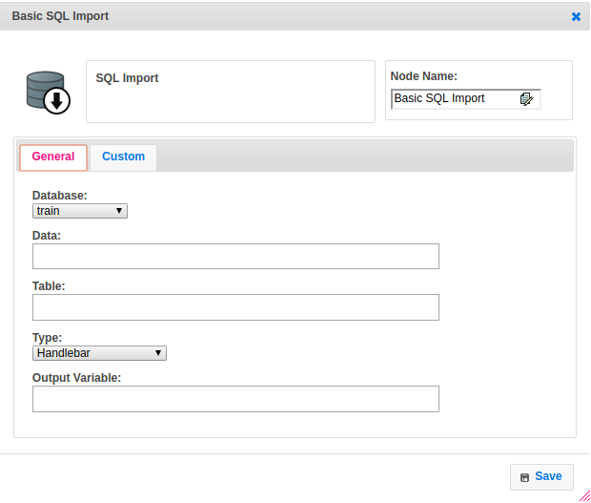

**Executor Description:**

* In executor class first will get the data as string and then convert from string to byte.
* Creates a temporary file and write the byte data into that file by using fileoutputstream then set the delimiter.
* Connect to mysql server by using mysql plugin then Import the csv data into a table which given by user. If user select header as true then exclude headers otherwise it include headers, by default it is false. User can add custom fields and also user can terminate lines as well fields based on requirement.
* After importing data into table successfully will delete the temporary file before exit and returns success.